***APPOINTMENT MANAGEMENT***

**A COMPUTER SCIENCE PROJECT REPORT**

**SUBMITTED BY**

**PUJAN SAVALIYA**

**IN PARTIAL FULFILMENT OF THE**

**CBSE GRADE XII**

**IN**

**Computer Science(083)**

**AT**



**J.B.DIAMONDS & KARP IMPEX VIDYA SANKUL**

LASKANA, KAMREJ ROAD, SURAT

 **J.B. Diamonds & KARP Impex Vidya Sankul**

Opp. Diamond Nagar, B/H ThakorDwar Farm, Surat - Kamrej Road, Laskana

**Phone No: 9228025712, Email id: jbkarpschool.cbse@gmail.com**

**Web: www.jbkarpschool.ac.in**

**CBSE-English Medium**

CERTIFICATE

Certificate

This is to certify that **MR.PUJAN SAVALIYA** is a student of J. B. Diamonds & KARP Impex Vidya Sankul, who has successfully completed the project work on title APPOINTMENT MANAGEMENT SYSTEM in COMPUTER SCIENCE (083) assigned to him as a part of AISSCE curriculum during the academic year 2022-23.

We found him very sincere, hardworking and disciplined boy.

We wish all the success for his future endeavors.

**…………………………………………… ……………………………………………….**

**Signature of the Internal Examiner Signature of the External Examiner**

**………………………………………….**

**Principal Signature**

ACKNOWLEDGEMENT

I would like to express my special thanks of gratitude to my Informatics Practices teacher Mr.AjayTiwari sir as well as our principal Mr.GaurangPatel sir for their guidance and support in completing this wonderful project entitled “Student management using Python-MySQL connectivity”.

I came to know about many things. I am really thankful to them.

A debt of gratitude is also owed to my parents and friends who helped me with their valuable suggestions.

Although this report has been prepared with utmost care and deep routed interest, even then I accept respondents and imperfections.

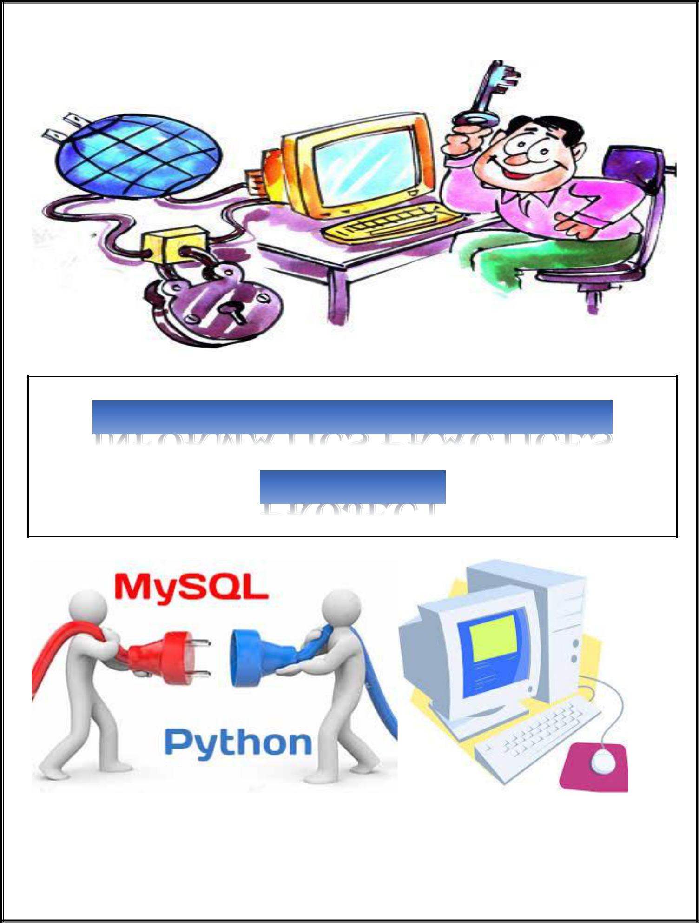

PROJECT FILE

CONTENTS



|  |  |
| --- | --- |
| S.No. | TOPIC |
| 1. | Aim |
| 2. | Introduction |
| 3. | Python coding |
| 4. | Input-output interference |
| 5. | Bibliography |



AIM

Student Management

Using

MYSQL Connectivity

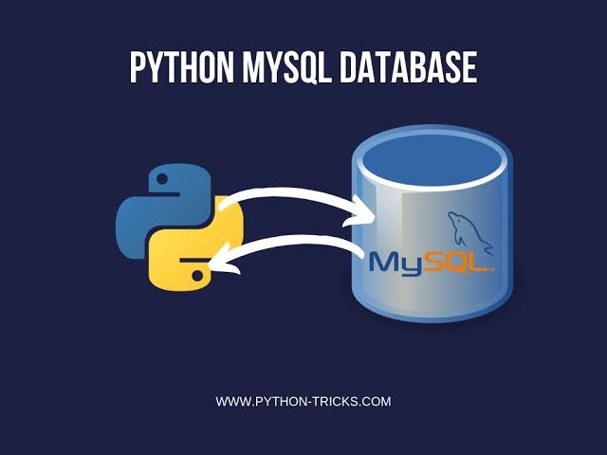

INTRODUCTION

* **What is Python?**
  + The Python Programming Language is a recent, general-purpose and higher-level programming language. It has features for database programming also.
  + This project aims on explaining how one can create a MySQL database from within a Python script and create a user interface software.
* **Why Python?**
  + - Due to its open source nature, Python has been ported to many platforms.
    - It is free and open source. It is available for free and runs on almost every current platform.
    - Python provides interfaces to all major commercial databases.
    - It can easily integrated with C, C++, COM, Java, MySQL, etc.
* **What is MySQL?**
  + MySQL is a freely available open source Relational Database Management System (RDBMS) that uses Structured Query Language (SQL).
  + It provides you with a rich set of features that support a secure environment for storing, maintaining, and accessing data.
* **Why MySQL?**
  + It is an open source software and is easily portable.
  + It is easy to use, manage and works quickly and efficiently.
  + It is used to create databases, manage security of a database.
  + It maintains integrity and reduces data redundancy.

MYSQL is a

back end

software

Python is a

front end

software

Interface PYTHON with

MYSQL

There are mainly seven steps that must be followed in order to create a database connectivity application.

**Step 1** –Start Python

**Step 2** –Import the packages required for databaseprogramming.

**Step 3** –Open a connection to database.

**Step 4** –Create a cursor instance.

**Step 5** –Execute a query.

**Step 6** –Extract data from result set.

**Step 7** –Clean up the environment

#LOGIN FORM

from tkinter import*

**SOURCE CODE:**

**LOGIN FORM**

import tkinter.messagebox # for messagebox

import os # for stringvariable

from tkinter import ttk # for combobox

import random # for reference

import time

import datetime

#from PIL import Image,ImageTk

def main():

root = Tk()

app = Window_1(root)

class Window_1:

def __init__(self, master):

self.master = master

self.master.title("Login Window")

self.master.geometry('1380x700+0+0')

self.master.config(bg = 'grey')

self.Frame = Frame(self.master, bg = 'grey')

self.Frame.pack()

self.Username = StringVar() # x = StringVar() Holds a string; default value is " "

self.Password = StringVar()

self.Lbl_Title = Label(self.Frame, text = 'Login Form', font = ('maiandra GD',55,'bold'), bg = 'grey', fg = 'cyan')

self.Lbl_Title.grid(row = 0, column = 0, columnspan =3, pady = 40)

self.Login_Frame_1 = LabelFrame(self.Frame, width = 1350, height = 150, relief = 'ridge', bg = 'grey', bd = 15, text='Login', fg = 'pink',

font = ('maiandra GD',20,'bold'))

self.Login_Frame_1.grid(row = 1, column =0)

self.Login_Frame_2 = LabelFrame(self.Frame, width = 1000, height = 150, relief = 'ridge',bg = 'grey', bd = 15, text='Events', fg = 'pink',

font = ('maiandra GD',20,'bold'))

self.Login_Frame_2.grid(row = 2, column = 0)

#===================================================LABEL and ENTRIES=======================================================================

self.Label_Username = Label(self.Login_Frame_1, text = 'Username', font = ('Lucida Handwriting',20,'bold'), bg = 'grey', fg = 'yellow', bd = 20)

self.Label_Username.grid(row = 0, column = 0)

self.text_Username = Entry(self.Login_Frame_1, font = ('arial',20,'bold'), textvariable = self.Username)

self.text_Username.grid(row = 0, column = 1, padx = 50)

self.text_Username.focus()

self.Label_Password = Label(self.Login_Frame_1, text = 'Password', font = ('Lucida Handwriting',20,'bold'), bg = 'grey', fg = 'Orange', bd = 20)

self.Label_Password.grid(row = 1, column = 0)

self.text_Password = Entry(self.Login_Frame_1, font = ('arial',20,'bold'),fg='blue',bg='white', show = "~", textvariable = self.Password)

self.text_Password.grid(row = 1, column = 1)

#=============================================================BUTTONS=======================================================================

self.btnLogin = Button(self.Login_Frame_2, text = 'Login', fg = 'blue',bg='white', width = 10, font = ('airia',15,'bold'),relief=RAISED,bd=7, command = self.Login)

self.btnLogin.grid(row = 3, column = 0, padx = 8, pady = 20)

self.btnReset = Button(self.Login_Frame_2, text = 'Reset', fg = 'purple',bg='white', width = 10, font = ('airia',15,'bold'),relief=RAISED,bd=7, command = self.Reset)

self.btnReset.grid(row = 3, column = 1, padx = 8, pady = 20)

self.btnExit = Button(self.Login_Frame_2, text = 'Exit', fg = 'darkblue',bg='white', width = 10, font = ('airia',15,'bold'),relief=RAISED,bd=7, command = self.Exit)

self.btnExit.grid(row = 3, column = 2, padx = 8, pady = 20)

#======================================================Code for Login Button==================================================================

def Login(self):

u = (self.Username.get())

p = (self.Password.get())

if (u == str('root') and p == str(12345)):

tkinter.messagebox.askyesno("Login Successfully","Thanks : For using Login Form.")

self.master.destroy()

self.__library__()

else:

tkinter.messagebox.askyesno("Login","Error : Wrong Password")

self.Username.set("")

self.Password.set("")

self.text_Username.focus()

#======================================================Code for Reset Button==================================================================

def Reset(self):

self.Username.set("")

self.Password.set("")

self.text_Username.focus()

#======================================================Code for Exit Button==================================================================

def Exit(self):

self.Exit = tkinter.messagebox.askokcancel("Login System", "Confirm if you want to Exit")

if self.Exit > 0:

self.master.destroy()

def __library__(self):

filename = 'FrontPage.py'

os.system(filename)

os.system('notepad'+filename)

if __name__ == '__main__': # https://micropyramid.com/blog/understand-self-and-__init__-method-in-python-class/

main()

**FrontPage**

from tkinter import*

from tkinter import messagebox

from PIL import ImageTk, Image

import NewRegistration as new_r

import ViewRegistration as view_r

import delete as ded

#---------------------Main Window----------------

window1 = Tk()

window1.title('Welcome')

window1.geometry('1260x630')

window1.config()

#---------------------Importing Images------------------

image1 = ImageTk.PhotoImage(Image.open("bg.png"))#

imagenew_reg = ImageTk.PhotoImage(Image.open("new.png"))

imageview_reg = ImageTk.PhotoImage(Image.open("view.png"))

delimage = ImageTk.PhotoImage(Image.open("delete.png"))

titleimage = ImageTk.PhotoImage(Image.open("hospitalname (2).jpg"))#

iconimage = ImageTk.PhotoImage(Image.open("icon.png"))#

cancelimage = ImageTk.PhotoImage(Image.open("button.png"))#

#----------------------Labels (window1)----------------------------

image1_label = Label(window1, image=image1)

image1_label.place(x=0, y=0)

welcome_label = Label(window1, image=titleimage)

welcome_label.place(x=400, y=20)

#---------------------Label Frame------------------------

labelframe=LabelFrame(window1,bg='white',width=350,height=500,borderwidth=10, relief="groove")

#labelframe.pack(padx=100,pady=100)

labelframe.place(x=480,y=150)

#---------------------Label(labelframe)-----------------

icon_label = Label(labelframe, image=iconimage)

icon_label.place(x=100,y=10)

#----------------------Buttons----------------------------

register = Button(labelframe, text='New Appointment',bd=0,image=imagenew_reg,command=new_r.Newregist) #command=new_r.Newregist, command=view_r.Viewregist, command=window1.destroy

register.place(x=25,y=200)

view = Button(labelframe, text='View Appointment',bd=0,image=imageview_reg,command=view_r.Viewregist)

view.place(x=25, y=270)

delete=Button(labelframe, text='delete Appointment',bd=0,image=delimage,command=ded.Viewregist)

delete.place(x=25, y=340)

close = Button(labelframe, image=cancelimage,bd=0,command=window1.destroy)

close.place(x=100, y=420)

window1.mainloop()

**NewRegistration**

from tkinter import*

from tkinter import messagebox

from tkinter import ttk

from PIL import ImageTk, Image

import mysql.connector

#iconimage = ImageTk.PhotoImage(Image.open("icon.png"))

mydb = mysql.connector.connect(host='localhost', user='root', password='12345')

cur=mydb.cursor()

cur.execute('create database if not exists project')

cur.execute("use project")

def Newregist():

new_r = Toplevel()

new_r.title('Registration Page')

new_r.geometry('1260x630')

new_r.config()

image1 = ImageTk.PhotoImage(Image.open("bg.png"))

#titleimage = ImageTk.PhotoImage(Image.open("hospitalname (2).jpg"))

back_button=ImageTk.PhotoImage(Image.open("back.png"))

submit_button=ImageTk.PhotoImage(Image.open("submit.png"))

image1_label = Label(new_r,image=image1)

#image1_label.image = image1

image1_label.place(x=0, y=0)

#new_label = Label(new_r, text='NEW REGISTRATION', fg='white', bg='black', bd=6, relief=RAISED, font=('ariel', 30))

iconimage = ImageTk.PhotoImage(Image.open("icon.png"))

#welcome_label = Label(new_r, image=titleimage)

#welcome_label.place(x=10, y=10)

labelframe1=LabelFrame(new_r,bg='white',width=500,height=550,borderwidth=5, relief="groove")

labelframe1.place(x=350,y=60)

icon_label=Label(labelframe1, image=iconimage).place(x=200,y=20)

#------------------Labels---------------------------

#icon_label = Label(labelframe1, image=iconimage).place(x=115,y=20)

new_name = Label(labelframe1, text="First Name", bd=5, bg='white', font=('ariel', 18))

new_name.place(x=0, y=170)

new_last = Label(labelframe1, text="Last Name", bd=5, bg='white', font=('ariel', 18))

new_last.place(x=0, y=220)

new_age = Label(labelframe1, text="Age", bg='white', bd=5, font=('ariel', 18))

new_age.place(x=0, y=270)

new_gender = Label(labelframe1, text="Gender", bg='white', bd=5, font=('ariel', 18))

new_gender.place(x=0, y=320)

new_num = Label(labelframe1, text="Phone Number", bg='white', bd=5, font=('ariel', 18))

new_num.place(x=0, y=370)

new_app = Label(labelframe1, text="Appointment Time", bg='white', bd=5, font=('ariel', 18))

new_app.place(x=0, y=420)

# ------------------Entry---------------------------

name_e = ttk.Entry(labelframe1, width=20,font=('calibre', 15, 'normal')) #, bd=6

name_e.place(x=230, y=170)

last_e = ttk.Entry(labelframe1, width=20,font=('calibre', 15, 'normal'))

last_e.place(x=230, y=220)

age_e = ttk.Entry(labelframe1, width=20,font=('calibre', 15, 'normal'))

age_e.place(x=230, y=270)

v = StringVar()

gender_e = ttk.Radiobutton(labelframe1, text='Male', variable=v, value='Male')# relief,font=('ariel', 12)

gender_e.place(x=230, y=320)

gender_e = ttk.Radiobutton(labelframe1, text='Female', variable=v, value='Female')

gender_e.place(x=280, y=320)

gender_e =ttk.Radiobutton(labelframe1, text='Other', variable=v, value='Other')

gender_e.place(x=340, y=320)

num_e = ttk.Entry(labelframe1, width=20,font=('calibre', 15, 'normal'))

num_e.place(x=230, y=370)

time=IntVar()

Date_combobox =ttk.Combobox(labelframe1,width=4,textvariable=time,state='readonly')

Date_combobox['values'] = ('1','2','3','4','5','6','7','8','9','10','11','12')

Date_combobox.current(0)

Date_combobox.place(x=230, y=430)

minutes=IntVar()

Date_combobox =ttk.Combobox(labelframe1,width=4,textvariable=minutes,state='readonly')

Date_combobox['values'] = ('5','10','15','20','25','30','35','40','45','50','55','60')

Date_combobox.current(0)

Date_combobox.place(x=290, y=430)

ampm = StringVar()

Date_combobox =ttk.Combobox(labelframe1,width=4,textvariable=ampm,state='readonly')

Date_combobox['values'] = ('AM', 'PM')

Date_combobox.current(0)

Date_combobox.place(x=350, y=430)

def insert():

name = name_e.get()

last = last_e.get()

age = age_e.get()

gender = v.get()

phone = num_e.get()

hours = time.get()

minutex = minutes.get()

amopm = ampm.get()

timex = str(hours) + ':' + str(minutex) + str(amopm)

mydb = mysql.connector.connect(host='localhost', user='root', password='12345',database='project')

cur = mydb.cursor()

#cur.execute('create database if not exists project')

cur.execute(

'create table if not exists hospital(name varchar(255), last varchar(255), age varchar(255), gender varchar(255), phone varchar(255), appt varchar(255))')

cur.execute('insert into hospital(name, last, age, gender, phone, appt) values(%s, %s, %s, %s, %s, %s)',

(name, last, age, gender, phone, timex))

mydb.commit()

messagebox.showinfo(title='Registration Complete', message='Appointment Successfully Placed')

new_r.destroy()

#------------------Buttons------------------

Button(labelframe1, bg='white', image=back_button,bd=0, command=new_r.destroy).place(x=100, y=470)

Button(labelframe1, bg='white', image=submit_button,bd=0, command=insert).place(x=300, y=470)

new_r.mainloop()

**View Registration**

from tkinter import*

from tkinter import messagebox

from PIL import ImageTk, Image

from tkinter import ttk

import mysql.connector

mydb = mysql.connector.connect(host='localhost', user='root', password='12345')

cur = mydb.cursor()

cur.execute("create database if not exists project")

cur.execute("use project")

def Viewregist():

view_r = Toplevel()

view_r.title('View appointment')

view_r.geometry('1260x630')

image1 = ImageTk.PhotoImage(Image.open("bg.png"))

image1_label = Label(view_r,image=image1)

image1_label.place(x=0, y=0)

#---------------------Label Frame------------------------

labelframe=LabelFrame(view_r,bg='white',width=500,height=550,borderwidth=5, relief="groove")

labelframe.place(x=350,y=50)

#

#titleimage = ImageTk.PhotoImage(Image.open("hospitalname (2).jpg"))

iconimage = ImageTk.PhotoImage(Image.open("icon.png"))

back_button=ImageTk.PhotoImage(Image.open("back.png"))

submit_button=ImageTk.PhotoImage(Image.open("submit.png"))

icon_label=Label(labelframe, image=iconimage).place(x=200,y=20)

#welcome_label = Label(view_r, image=titleimage)

#welcome_label.place(x=10, y=10)

# ------------------Labels---------------------------

new_name = Label(labelframe, text="First Name", bd=5, bg='white', font=('ariel', 18))

new_name.place(x=20, y=200)

new_last = Label(labelframe, text="Last Name", bd=5, bg='white', font=('ariel', 18))

new_last.place(x=20, y=240)

# new_age = Label(view_r, text="Patient's Age", bg='white', bd=5, font=('ariel', 18))

# new_age.place(x=550, y=250)

# ------------------Entry---------------------------

name_e = ttk.Entry(labelframe,width=20,font=('calibre', 15, 'normal'))

name_e.place(x=230, y=200)

last_e = ttk.Entry(labelframe,width=20,font=('calibre', 15, 'normal'))

last_e.place(x=230, y=240)

# num_e = Entry(view_r, width=40, bd=6)

# num_e.place(x=750, y=250)

def submit():

view = Toplevel()

view.title('Registration Page')

view.geometry('1260x630')

view.config(bg='sky blue')

image1 = ImageTk.PhotoImage(Image.open("bg.png"))

image1_label = Label(view,image=image1)

image1_label.place(x=0, y=0)

#new_label = Label(view, text='VIEW REGISTRATION', fg='white', bg='black', bd=6, relief=RAISED,font=('ariel', 30))

#new_label.place(x=570, y=20)

#------------------Image Label-----------------------

labelframe=LabelFrame(view,bg='white',width=500,height=600,borderwidth=5, relief="groove")

labelframe.place(x=350,y=50)

#------------------

#titleimage = ImageTk.PhotoImage(Image.open("hospitalname (2).jpg"))

iconimage = ImageTk.PhotoImage(Image.open("icon.png"))

icon_label=Label(labelframe, image=iconimage).place(x=200,y=20)

back_button=ImageTk.PhotoImage(Image.open("back.png"))

#welcome_label = Label(view, image=titleimage)

#welcome_label.place(x=10, y=10)

# ------------------Labels---------------------------

new_name = Label(labelframe, text="First Name", bd=2, bg='white', font=('ariel', 18))

new_name.place(x=0, y=170)

new_last = Label(labelframe, text="Last Name", bd=2, bg='white', font=('ariel', 18))

new_last.place(x=0, y=220)

new_age = Label(labelframe, text="Age", bg='white',bd=2, font=('ariel', 18))

new_age.place(x=0, y=270)

new_gender = Label(labelframe, text="Gender", bg='white', bd=2, font=('ariel', 18))

new_gender.place(x=0, y=320)

new_num = Label(labelframe, text="Phone Number", bg='white', bd=2, font=('ariel', 18))

new_num.place(x=0, y=370)

new_app = Label(labelframe, text="Appointment Time", bg='white', bd=2, font=('ariel', 18))

new_app.place(x=0, y=420)

iname = name_e.get()

ilast = last_e.get()

# iage = num_e.get()

mydb = mysql.connector.connect(host='localhost', user='root', password='12345',database='project')

cur = mydb.cursor()

#cur.execute('create database if not exists project')

#cur.execute('create table if not exists hospital(name varchar(255), last varchar(255), age varchar(255), gender varchar(255), phone varchar(255), appt varchar(255))')

cur.execute("select name from hospital where name=%s and last=%s ",(iname, ilast))

dname = cur.fetchone()

cur.execute("select last from hospital where name=%s and last=%s ", (iname, ilast))

dlast = cur.fetchone()

cur.execute('select age from hospital where name=%s and last=%s ',(iname, ilast))

dage = cur.fetchone()

cur.execute('select gender from hospital where name=%s and last=%s',(iname, ilast))

dgender = cur.fetchone()

cur.execute('select phone from hospital where name=%s and last=%s ',(iname, ilast))

dphone = cur.fetchone()

cur.execute('select appt from hospital where name=%s and last=%s',(iname, ilast))

dappt = cur.fetchone()

# ------------------Labels---------------------------

name = Label(labelframe, text=dname, bd=5, bg='white', font=('ariel', 15))

name.place(x=230, y=170)

last = Label(labelframe, text=dlast, bd=5, bg='white', font=('ariel', 15))

last.place(x=230, y=220)

age = Label(labelframe, text=dage, bd=5, bg='white', font=('ariel', 15))

age.place(x=230, y=270)

gender = Label(labelframe, text=dgender, bd=5, bg='white', font=('ariel', 15))

gender.place(x=230, y=320)

num = Label(labelframe, bd=5, text=dphone, bg='white', font=('ariel', 15))

num.place(x=230, y=370)

appt = Label(labelframe, bd=5, text=dappt, bg='white', font=('ariel', 15))

appt.place(x=290, y=430)

Button(labelframe,image=back_button,bd=0,bg='white', command=view.destroy).place(x=240, y=500)

view.mainloop()

# ------------------Button---------------------------

Button(labelframe, bg='white', image=back_button,bd=0, command=view_r.destroy).place(x=100, y=470)

Button(labelframe, bg='white', image=submit_button,bd=0,command=submit).place(x=300, y=470)

view_r.mainloop()

**Delete**

from tkinter import*

from tkinter import messagebox

from PIL import ImageTk, Image

from tkinter import ttk

import mysql.connector

mydb = mysql.connector.connect(host='localhost', user='root', password='12345')

cur = mydb.cursor()

cur.execute("create database if not exists project")

cur.execute("use project")

def Viewregist():

view_r = Toplevel()

view_r.title('Delete ')

view_r.geometry('1260x630')

image1 = ImageTk.PhotoImage(Image.open("bg.png"))

image1_label = Label(view_r,image=image1)

image1_label.place(x=0, y=0)

delbut1=ImageTk.PhotoImage(Image.open("delbut.png"))

#---------------------Label Frame------------------------

labelframe=LabelFrame(view_r,bg='white',width=500,height=550,borderwidth=5, relief="groove")

labelframe.place(x=350,y=50)

#

#titleimage = ImageTk.PhotoImage(Image.open("hospitalname (2).jpg"))

iconimage = ImageTk.PhotoImage(Image.open("icon.png"))

back_button=ImageTk.PhotoImage(Image.open("back.png"))

submit_button=ImageTk.PhotoImage(Image.open("submit.png"))

icon_label=Label(labelframe, image=iconimage).place(x=200,y=20)

#welcome_label = Label(view_r, image=titleimage)

#welcome_label.place(x=10, y=10)

# ------------------Labels---------------------------

new_name = Label(labelframe, text="First Name", bd=5, bg='white', font=('ariel', 18))

new_name.place(x=20, y=200)

new_last = Label(labelframe, text="Last Name", bd=5, bg='white', font=('ariel', 18))

new_last.place(x=20, y=240)

# new_age = Label(view_r, text="Patient's Age", bg='white', bd=5, font=('ariel', 18))

# new_age.place(x=550, y=250)

# ------------------Entry---------------------------

name_e = ttk.Entry(labelframe,width=20,font=('calibre', 15, 'normal'))

name_e.place(x=230, y=200)

last_e = ttk.Entry(labelframe,width=20,font=('calibre', 15, 'normal'))

last_e.place(x=230, y=240)

# num_e = Entry(view_r, width=40, bd=6)

# num_e.place(x=750, y=250)

def delete():

mydb = mysql.connector.connect(host='localhost', user='root', password='12345',database='project')

iname = name_e.get()

ilast = last_e.get()

cur = mydb.cursor()

cur.execute("DELETE FROM hospital WHERE name = %s and last = %s ",(iname, ilast))

mydb.commit()

mydb.close()

messagebox.showinfo("Delete","Record has been deleted.")

def submit():

view = Toplevel()

view.title('Delete')

view.geometry('1260x630')

view.config(bg='sky blue')

image1 = ImageTk.PhotoImage(Image.open("bg.png"))

image1_label = Label(view,image=image1)

image1_label.place(x=0, y=0)

#new_label = Label(view, text='VIEW REGISTRATION', fg='white', bg='black', bd=6, relief=RAISED,font=('ariel', 30))

#new_label.place(x=570, y=20)

#------------------Image Label-----------------------

labelframe=LabelFrame(view,bg='white',width=500,height=600,borderwidth=5, relief="groove")

labelframe.place(x=350,y=50)

#------------------

#titleimage = ImageTk.PhotoImage(Image.open("hospitalname (2).jpg"))

iconimage = ImageTk.PhotoImage(Image.open("icon.png"))

icon_label=Label(labelframe, image=iconimage).place(x=200,y=20)

back_button=ImageTk.PhotoImage(Image.open("back.png"))

#welcome_label = Label(view, image=titleimage)

#welcome_label.place(x=10, y=10)

# ------------------Labels---------------------------

new_name = Label(labelframe, text="First Name", bd=2, bg='white', font=('ariel', 18))

new_name.place(x=0, y=170)

new_last = Label(labelframe, text="Last Name", bd=2, bg='white', font=('ariel', 18))

new_last.place(x=0, y=220)

new_age = Label(labelframe, text="Age", bg='white',bd=2, font=('ariel', 18))

new_age.place(x=0, y=270)

new_gender = Label(labelframe, text="Gender", bg='white', bd=2, font=('ariel', 18))

new_gender.place(x=0, y=320)

new_num = Label(labelframe, text="Phone Number", bg='white', bd=2, font=('ariel', 18))

new_num.place(x=0, y=370)

new_app = Label(labelframe, text="Appointment Time", bg='white', bd=2, font=('ariel', 18))

new_app.place(x=0, y=420)

iname = name_e.get()

ilast = last_e.get()

# iage = num_e.get()

mydb = mysql.connector.connect(host='localhost', user='root', password='12345',database='project')

cur = mydb.cursor()

#cur.execute('create database if not exists project')

#cur.execute('create table if not exists hospital(name varchar(255), last varchar(255), age varchar(255), gender varchar(255), phone varchar(255), appt varchar(255))')

cur.execute("select name from hospital where name=%s and last=%s ",(iname, ilast))

dname = cur.fetchone()

cur.execute("select last from hospital where name=%s and last=%s ", (iname, ilast))

dlast = cur.fetchone()

cur.execute('select age from hospital where name=%s and last=%s ',(iname, ilast))

dage = cur.fetchone()

cur.execute('select gender from hospital where name=%s and last=%s',(iname, ilast))

dgender = cur.fetchone()

cur.execute('select phone from hospital where name=%s and last=%s ',(iname, ilast))

dphone = cur.fetchone()

cur.execute('select appt from hospital where name=%s and last=%s',(iname, ilast))

dappt = cur.fetchone()

# ------------------Labels---------------------------

name = Label(labelframe, text=dname, bd=5, bg='white', font=('ariel', 15))

name.place(x=230, y=170)

last = Label(labelframe, text=dlast, bd=5, bg='white', font=('ariel', 15))

last.place(x=230, y=220)

age = Label(labelframe, text=dage, bd=5, bg='white', font=('ariel', 15))

age.place(x=230, y=270)

gender = Label(labelframe, text=dgender, bd=5, bg='white', font=('ariel', 15))

gender.place(x=230, y=320)

num = Label(labelframe, bd=5, text=dphone, bg='white', font=('ariel', 15))

num.place(x=230, y=370)

appt = Label(labelframe, bd=5, text=dappt, bg='white', font=('ariel', 15))

appt.place(x=290, y=430)

Button(labelframe,image=back_button,bd=0,bg='white', command=view.destroy).place(x=150, y=500)

Button(labelframe, bg='white', text='del',image=delbut1,bd=0,command=delete).place(x=300, y=500)

view.mainloop()

# ------------------Button---------------------------

Button(labelframe, bg='white', image=back_button,bd=0, command=view_r.destroy).place(x=100, y=470)

Button(labelframe, bg='white', image=submit_button,bd=0,command=submit).place(x=300, y=470)

view_r.mainloop()

**OUTPUT:**

**Login form:**

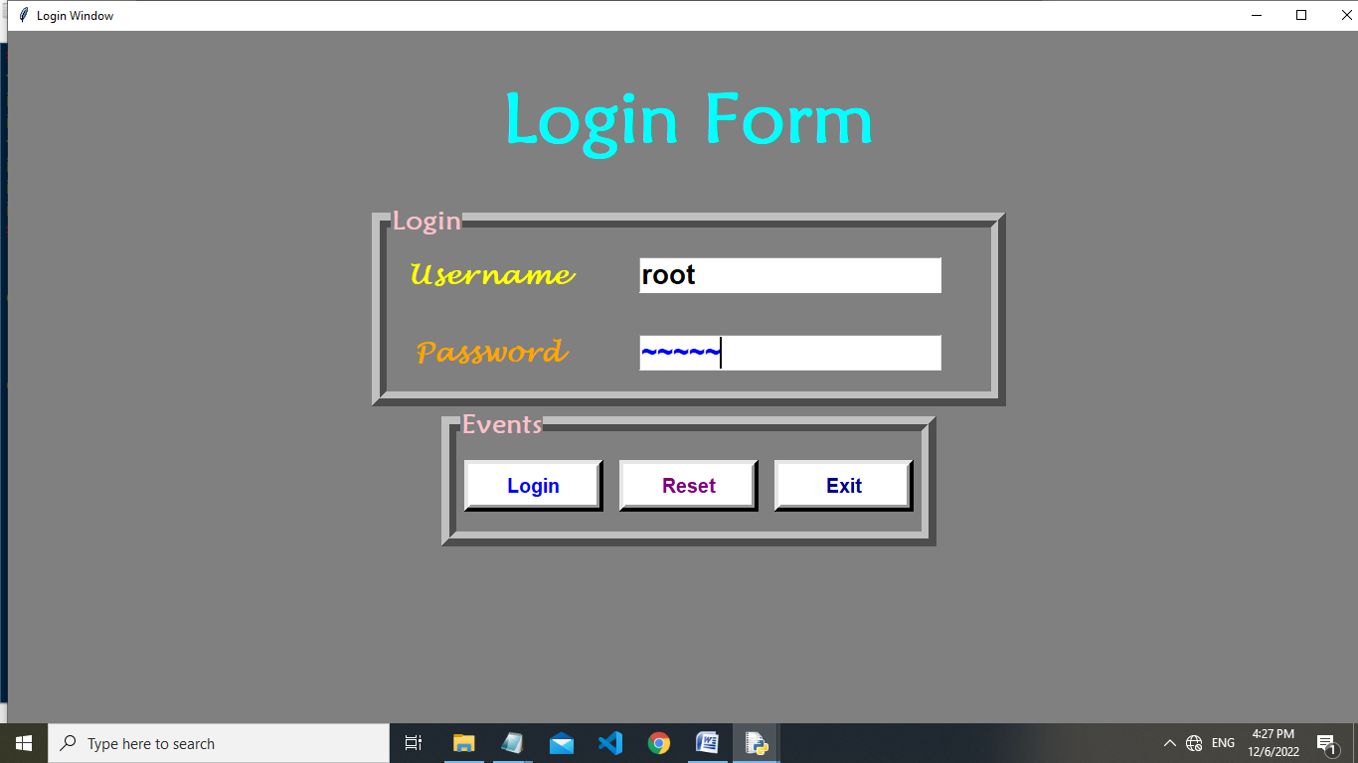

**First page:**

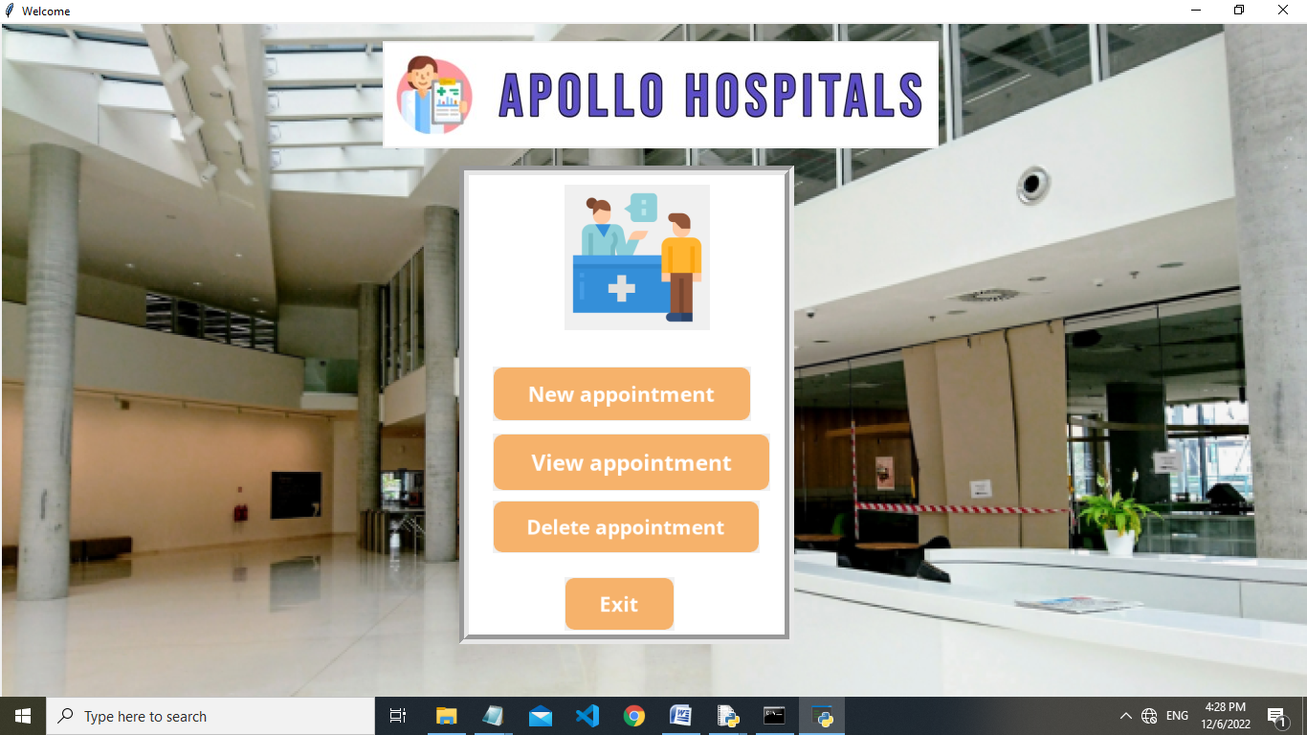

**New Appointment:**

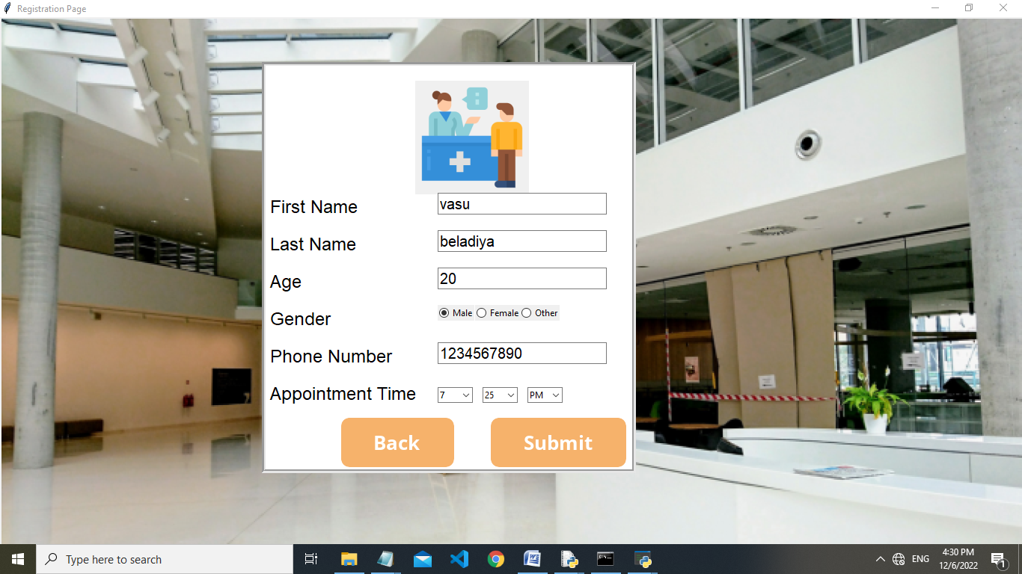

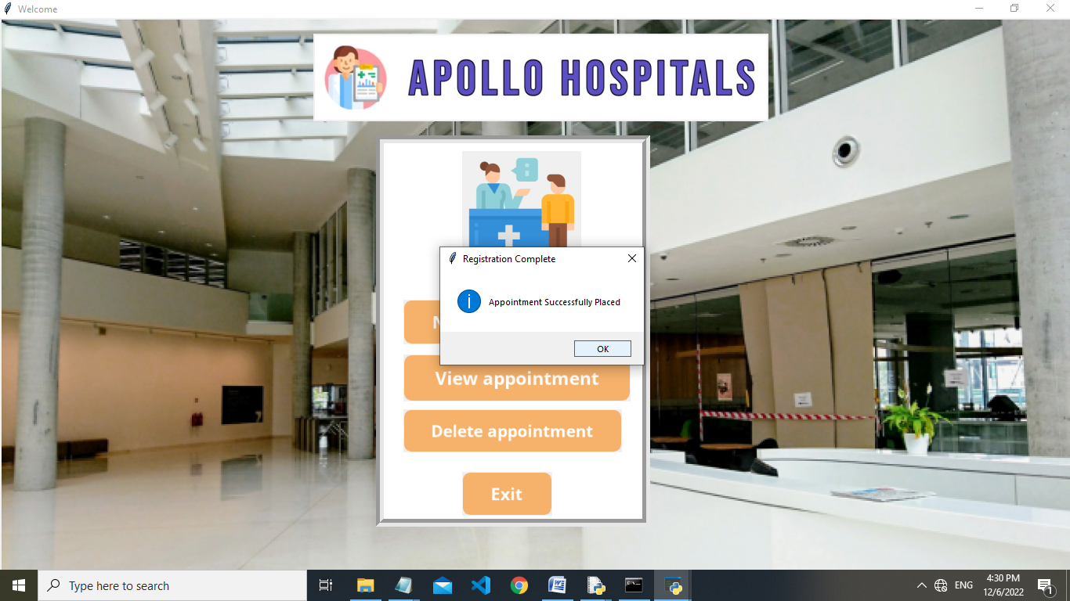

**View Appointment:**

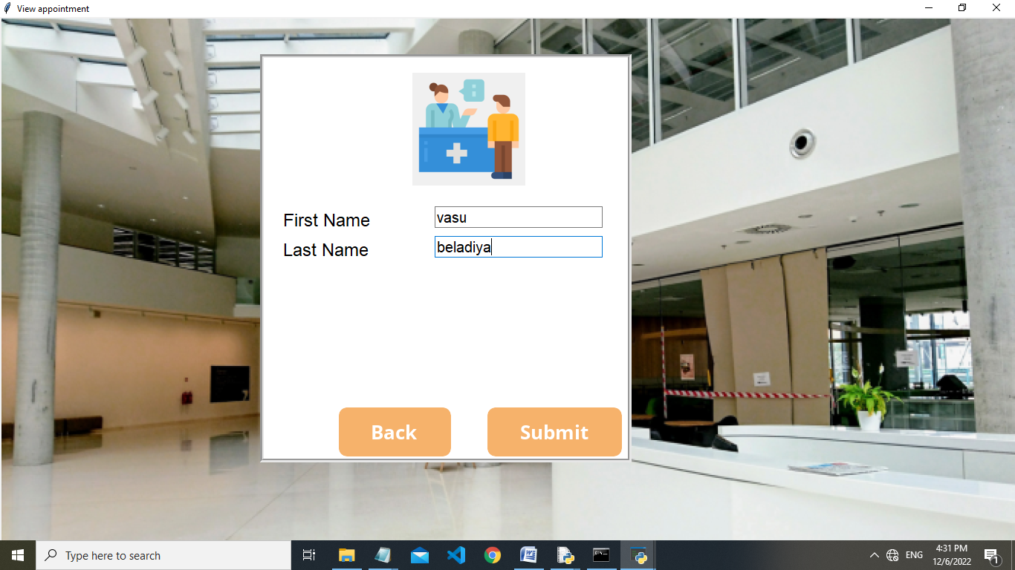

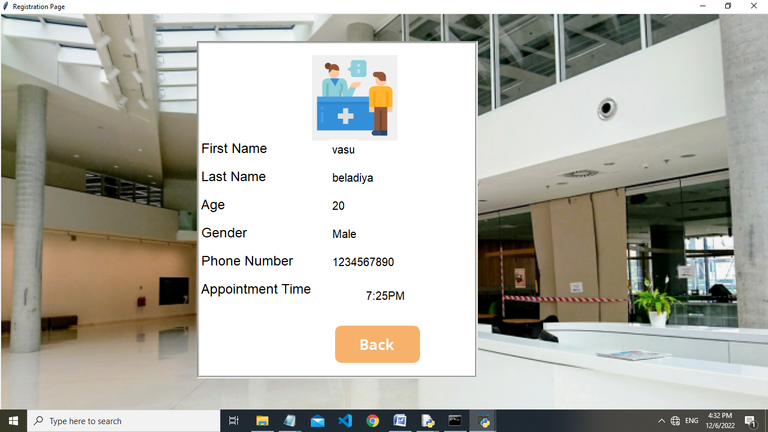

**Delete Appointment:**

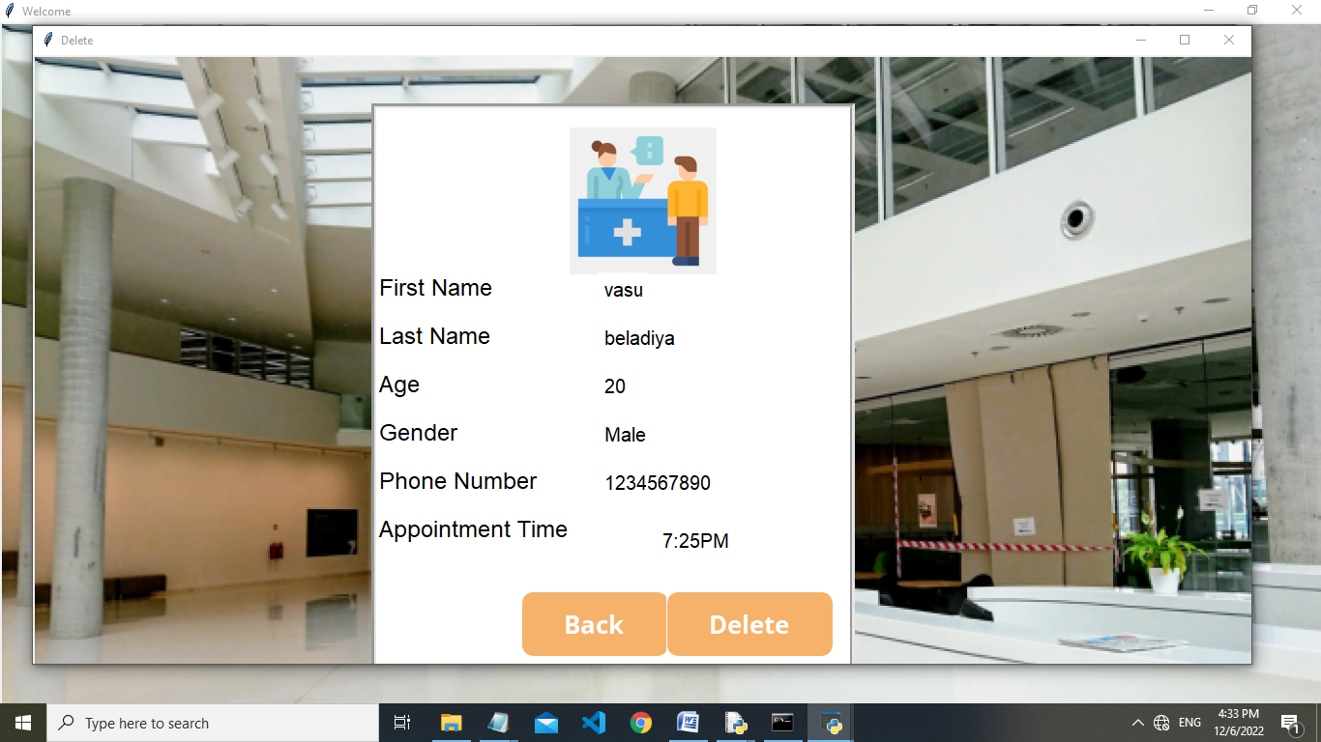

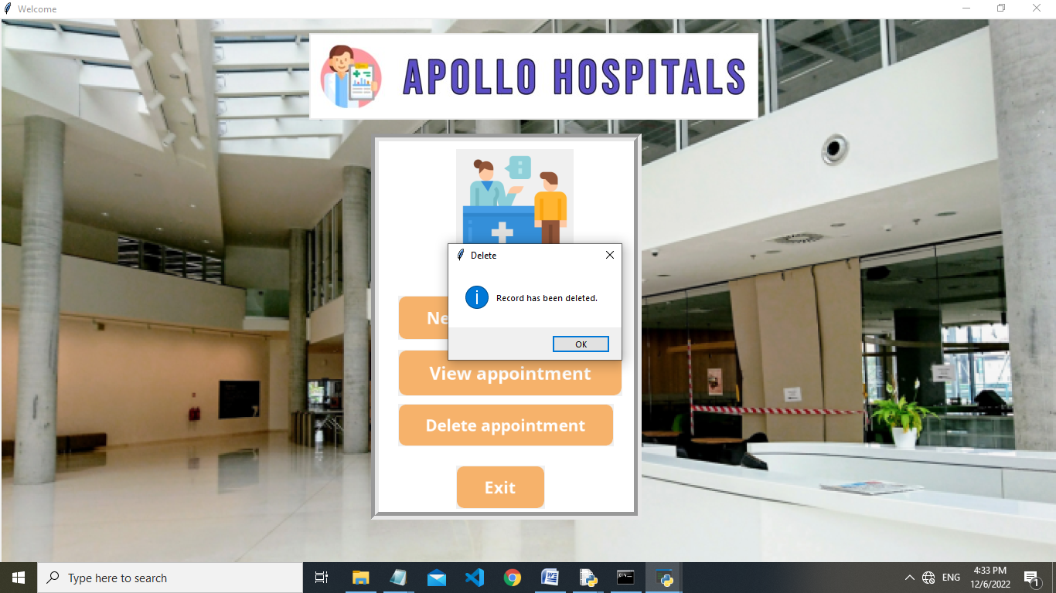

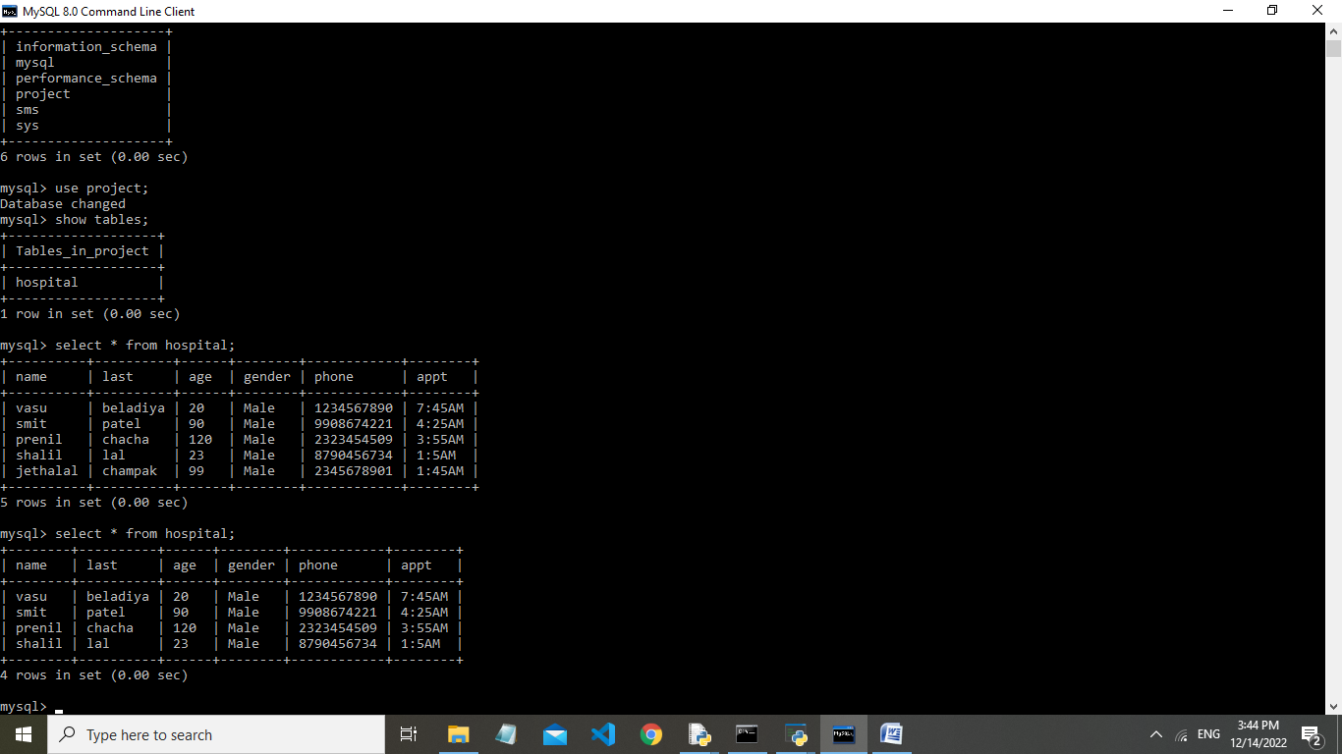**Database Structure:**

**BILIOGRAPHY**

* **Computer Science with Python – Class XII by: SumitaArora**
* **Website:**
* [**www.youtube.com**](http://www.youtube.com)
* [**www.Google.com**](http://www.Google.com)
* ****[**www.pythongo.com**](http://www.pythongo.com)